http://www.dotnettricks.com/learn/oops/object-oriented-programming-concepts:
Object-Oriented Programming Concepts (www.dotnettricks.com)
Author : Shailendra Chauhan
Posted On : 15 Feb 2011
Updated On : 10 Jul 2012
http://www.dotnettricks.com/learn/sqlserver/introduction-to-sql-server:
Introduction to SQL Server
Microsoft SQL Server is a Relational Database Management System(RDBMS) developed by Microsoft. It is designed to run on a central server, so that multiple users can access the same data simultaneously. Generally users access the database through an application.
SQL Server Release History
Version | Year | Release Name
1.0 for OS/2 | 1989 | SQL Server 1.0(16bit)
1.1 for OS/2 | 1991 | SQL Server 1.1(16bit)
4.21 for WinNT | 1993 | SQL Server 4.21
6.0 | 1995 | SQL Server 6.0
6.5 | 1996 | SQL Server 6.4
7.0 | 1998 | SQL Server 7.0
8.0 | 2000 | SQL Server 2000
8.0 | 2003 | SQL Server 2000 (64-bit)
9.0 | 2005 | SQL Server 2005
10.0 | 2008 | SQL Server 2008
10.5 | 2010 | SQL Server 2008 R2

Sql Server Components
- Protocol Layer
Protocol layer implements the external interface to SQL Server. TDS is an application layer protocol, that is used to transfer data between a database server and a client.
- Data Storage
The main unit of data storage is a database, which is a collection of data. The data in the SQL Server database is stored in primary data files with an extension .mdf and Secondary data files, with an extension .ndf extension are used to store optional metadata. Log files in SQL Server are recognized with the .ldf extension.
- Buffer Management
SQL Server buffers pages in RAM to minimize disc Input/Output. A 8 KB page could be buffered in-memory and the set of all pages currently buffered is called the buffer cache. On the basis of available memory, SQL Server decides how many pages will be cached in memory. The buffer cache is managed by the Buffer Manager.
- Logging and Transaction
SQL Server uses transaction to make sure that any operation either totally completes or is undone if fails, but never leaves the database in an intermediate state. Any changes made to a page will update the in-memory cache of the page and simultaneously all the operations performed will be written to a log, along with the transaction ID. Each log entry is recognized by an increasing Log Sequence Number (LSN) which makes sure that no event overwrites another event. SQL Server makes sure that the log will be written onto the disc before the actual page is written back.
- Concurrency and locking
when multiple users update the same data, or attempt to read data that is in the process of being changed by another user. In SQL Server we have two modes of concurrency control - pessimistic concurrency and optimistic concurrency. In pessimistic concurrency control, SQL Server controls concurrent access by using locks (shared or exclusive).
In Optimistic concurrency control, a new version of a row is created whenever the divrow is updated. Both the versions of the row are stored and maintained into a system defined database Tempdb.
- Data Retrieval
Data retrieval from SQL Server is done using T-SQL. SQL Server also allows us to write stored procedures to query the data.
- SQL CLR (Common Language Runtime)
SQL Server 2005 also has a new component named SQL CLR via which it integrates with .NET Framework. When we write code for SQL CLR, data stored in SQL Server databases can be accessed by using the ADO.NET APIs like any other application that accesses SQL Server data.

Basics of SQL Commands
http://www.dotnettricks.com/learn/sqlserver/basics-of-sql-commands:
SQL commands are a set of instructions that are used to interact with the database like Sql Server, MySql, Oracle etc. SQL commands are responsible to create and to do all the manipulation on the database. These are also responsible to give/take out access rights on a particular database

Sql Commands Category
We have different sql commands for different-different purpose. We can grouped Sql Commands into five major categories depending on their functionality.
- Data Definition Language (DDL)
These SQL commands are used to create, modify, and drop the structure of database objects like table, view, procedure, indexes etc. In this category we have CREATE, ALTER, DROP and TRUNCATE commands.

Note
  - Only with DDL commands we need to write keyword (like table, procedure, view, index, function) with the syntax of command.
  - These commands are used to create/modify the structure of the database object.

Example
  - CREATE TABLE TABLE_NAME
  - (
  - COL1 VARCHAR(10),
  - COL2 VARCHAR(20),
  - );
  - --Here "TABLE" is a keyword that is used to create table "TABLE_NAME"
  - CREATE VIEW VIEW_NAME
  - AS
  - BEGIN
  - SELECT * FROM EMP_TABLE
  - END
  - --Here "VIEW" is a keyword that is used to create VIEW "VIEW_NAME"
- Data Manipulation Language (DML)
These SQL commands are used to store, modify, and delete data from database tables. In this category we have INSERT, UPDATE, and DELETE commands.
- Data Query Language (DQL)
These SQL commands are used to fetch/retrieve data from database tables. In this category we have only SEELCT command.
- Transaction Control Language (TCL)
These SQL commands are used to handle changes which affect the data in database. Basically we use these commands with in the transaction or to make a stable point during changes in database at which we can rollback the database state if required. In this category we have SAVEPOINT, ROLLBACK and COMMIT commands.
- Data Control Language (DCL)
These SQL commands are used to implement security on database objects like table,view,stored procedure etc. In this category we have GRANT and REVOKE commands.

Note
  - Grant Command : This command is used to give permission to specific users on specific database objects like table, view etc.
  - Revoke Command : This command is used to take out permission from specific users on specific database objects like table, view etc.

Different Types of SQL Keys
http://www.dotnettricks.com/learn/sqlserver/different-types-of-sql-keys:
A key is a single or combination of multiple fields in a table. It is used to fetch or retrieve records/data-rows from data table according to the condition/requirement. Keys are also used to create relationship among different database tables or views.

Types of SQL Keys
We have following types of keys in SQL which are used to fetch records from tables and to make relationship among tables or views.
    - Super Key
Super key is a set of one or more than one keys that can be used to identify a record uniquely in a table.Example : Primary key, Unique key, Alternate key are subset of Super Keys.
    - Candidate Key
A Candidate Key is a set of one or more fields/columns that can identify a record uniquely in a table. There can be multiple Candidate Keys in one table. Each Candidate Key can work as Primary Key.
Example: In below diagram ID, RollNo and EnrollNo are Candidate Keys since all these three fields can be work as Primary Key.
    - Primary Key
Primary key is a set of one or more fields/columns of a table that uniquely identify a record in database table. It can not accept null, duplicate values. Only one Candidate Key can be Primary Key.
    - Alternate key
A Alternate key is a key that can be work as a primary key. Basically it is a candidate key that currently is not primary key.
Example: In below diagram RollNo and EnrollNo becomes Alternate Keys when we define ID as Primary Key.
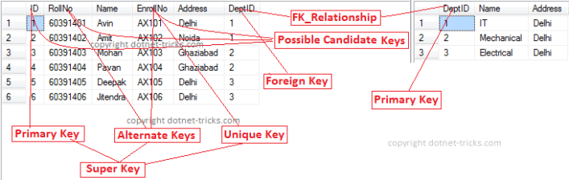
    - Composite/Compound Key
Composite Key is a combination of more than one fields/columns of a table. It can be a Candidate key, Primary key.
    - Unique Key
Uniquekey is a set of one or more fields/columns of a table that uniquely identify a record in database table. It is like Primary key but it can accept only one null value and it can not have duplicate values. For more help refer the article Difference between primary key and unique key.
    - Foreign Key
Foreign Key is a field in database table that is Primary key in another table. It can accept multiple null, duplicate values. For more help refer the article Difference between primary key and foreign key.
Example : We can have a DeptID column in the Employee table which is pointing to DeptID column in a department table where it a primary key.

Defining Keys in SQL Server
- --Department Table
- CREATE TABLE Department
- (
- DeptID int PRIMARY KEY, --primary key
- Name varchar (50) NOT NULL,
- Address varchar (200) NOT NULL
- )
- --Student Table
- CREATE TABLE Student
- (
- ID int PRIMARY KEY, --primary key
- RollNo varchar(10) NOT NULL,
- Name varchar(50) NOT NULL,
- EnrollNo varchar(50) UNIQUE, --unique key
- Address varchar(200) NOT NULL,
- DeptID int FOREIGN KEY REFERENCES Department(DeptID) --foreign key
- )

Note
- Practically in database, we have only three types of keys Primary Key, Unique Key and Foreign Key. Other types of keys are only concepts of RDBMS which you should know.

SQL Integrity Constraints or Constraints
http://www.dotnettricks.com/learn/sqlserver/sql-integrity-constraints-or-constraints:
Constraints are some rules that enforce on the data to be enter into the database table. Basically constraints are used to restrict the type of data that can insert into a database table.Constraints can be defined in two ways:
  - Column Level
The constraints can be specified immediately after the column definition with the CREATE TABLE statement. This is called column-level constraints.
  - Table Level
The constraints can be specified after all the columns are defined with the ALTER TABLE statement. This is called table-level constraints.

Types of SQL Constraints
In Microsoft SQL Server we have six types of constraints
- Primary Key Constraints
Primary key is a set of one or more fields/columns of a table that uniquely identify each record/row in database table. It can not accept null, duplicate values.
Primary key constraint at column level
  - CREATE TABLE table_name
  - (
  - col1 datatype [CONSTRAINT constraint_name] PRIMARY KEY,
  - col2 datatype
  - );
Primary key constraint at table level
  - ALTER TABLE table_name
  - ADD[CONSTRAINT constraint_name] PRIMARY KEY (col1,col2)
- Unique Key Constraints
Unique key is a set of one or more fields/columns of a table that uniquely identify each record/row in database table.It is like Primary key but it can accept only one null value and it can not have duplicate values
Unique key constraint at column level
  - CREATE TABLE table_name
  - (
  - col1 datatype [CONSTRAINT constraint_name] UNIQUE,
  - col2 datatype
  - );
Unique key constraint at table level
    - ALTER TABLE table_name
    - ADD[CONSTRAINT constraint_name] UNIQUE (col1,col2)
- Foreign Key Constraints
Foreign Key is a field in database table that is Primary key in another table. It can accept multiple null, duplicate values.
Foreign key constraint at column level
  - CREATE TABLE table_name
  - (
  - col1 datatype [CONSTRAINT constraint_name] REFERENCES referenced_table_name(referenced_table_column_name),
  - col2 datatype
  - );
Foreign key constraint at table level
- ALTER TABLE table_name
- ADD[CONSTRAINT constraint_name] REFERENCES referenced_table_name(referenced_table_col)
- Not Null Constraints
This constraint ensures that all rows in the database table must contain value for the column which is specified as not null means a null value is not allowed in that column.
Not Null constraint at column level
  - CREATE TABLE table_name
  - (
  - col1 datatype [CONSTRAINT constraint_name] NOT NULL,
  - col2 datatype
  - );
Not Null constraint at table level
  - ALTER TABLE table_name
  - ALTER COLUMN col1 datatype NOT NULL
- Check Constraints
This constraint defines a business rule on a column in the database table that each row of the table must follow this rule.
Check constraint at column level
  - CREATE TABLE table_name
  - (
  - col1 datatype [CONSTRAINT constraint_name] CHECK (condition),
  - col2 datatype
  - );
Check constraint at table level
  - ALTER TABLE table_name ADD CONSTRAINT constraint_name CHECK(condition)

Different Types of SQL Joins
http://www.dotnettricks.com/learn/sqlserver/different-types-of-sql-joins:
Sql joins are used to fetch/retrieve data from two or more data tables, based on a join condition. A join condition is a relationship among some columns in the data tables that take part in Sql join. Basically data tables are related to each other with keys. We use these keys relationship in sql joins. Also, refer the article SQL Joins with C# LINQ.

Types of Joins
In Sql Server we have only three types of joins. Using these joins we fetch the data from multiple tables based on condition.
    - Inner Join
Inner join returns only those records/rows that match/exists in both the tables. Syntax for Inner Join is as
  - Select * from table_1 as t1
  - inner join table_2 as t2
  - on t1.IDcol=t2.IDcol
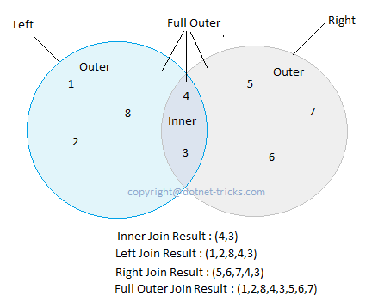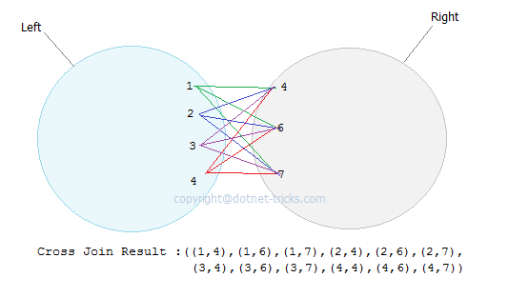
    - Outer Join
We have three types of Outer Join.
    - Left Outer Join
Left outer join returns all records/rows from left table and from right table returns only matched records. If there are no columns matching in the right table, it returns NULL values. Syntax for Left outer Join is as :
    - Select * from table_1 as t1
    - left outer join table_2 as t2
    - on t1.IDcol=t2.IDcol
- Right Outer Join
Right outer join returns all records/rows from right table and from left table returns only matched records. If there are no columns matching in the left table, it returns NULL values. Syntax for right outer Join is as :
    - Select * from table_1 as t1
    - right outer join table_2 as t2
    - on t1.IDcol=t2.IDcol
- Full Outer Join
Full outer join combines left outer join and right outer join. This join returns all records/rows from both the tables.If there are no columns matching in the both tables, it returns NULL values. Syntax for full outer Join is as :
    - Select * from table_1 as t1
    - full outer join table_2 as t2
    - on t1.IDcol=t2.IDcol
    - Cross Join
Cross join is a cartesian join means cartesian product of both the tables. This join does not need any condition to join two tables. This join returns records/rows that are multiplication of record number from both the tables means each row on left table will related to each row of right table. Syntax for right outer Join is as :
  - Select * from table_1
  - cross join table_2
      - Self Join
Self join is used to join a database table to itself, particularly when the table has a Foreign key that references its own Primary Key. Basically we have only three types of joins : Inner join, Outer join and Cross join. We use any of these three JOINS to join a table to itself. Hence Self join is not a type of Sql join.

Join Examples
Suppose we following three tables and data in these three tables is shown in figure. You can download the SQL script used in this article by using link.
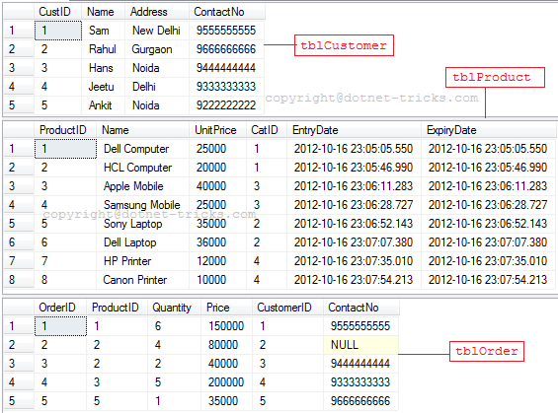

Inner Join
- SELECT t1.OrderID, t0.ProductID, t0.Name, t0.UnitPrice, t1.Quantity, t1.Price
- FROM tblProduct AS t0
- INNER JOIN tblOrder AS t1 ON t0.ProductID = t1.ProductID
- ORDER BY t1.OrderID
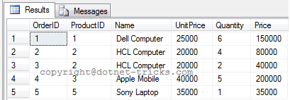

Inner Join among more than two tables
- SELECT t1.OrderID, t0.ProductID, t0.Name, t0.UnitPrice, t1.Quantity, t1.Price, t2.Name AS Customer
- FROM tblProduct AS t0
- INNER JOIN tblOrder AS t1 ON t0.ProductID = t1.ProductID
- INNER JOIN tblCustomer AS t2 ON t1.CustomerID = t2.CustID
- ORDER BY t1.OrderID
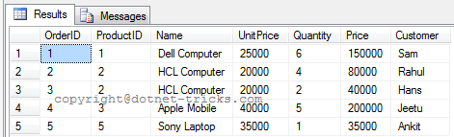

Inner Join on multiple conditions
- SELECT t1.OrderID, t0.ProductID, t0.Name, t0.UnitPrice, t1.Quantity, t1.Price, t2.Name AS Customer
- FROM tblProduct AS t0
- INNER JOIN tblOrder AS t1 ON t0.ProductID = t1.ProductID
- INNER JOIN tblCustomer AS t2 ON t1.CustomerID = t2.CustID AND t1.ContactNo = t2.ContactNo
- ORDER BY t1.OrderID
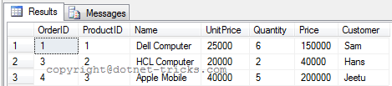

Left Outer Join
- SELECT t1.OrderID AS OrderID , t0.ProductID , t0.Name , t0.UnitPrice , t1.Quantity AS Quantity , t1.Price AS Price
- FROM tblProduct AS t0
- LEFT OUTER JOIN tblOrder AS t1 ON t0.ProductID = t1.ProductID
- ORDER BY t0.ProductID

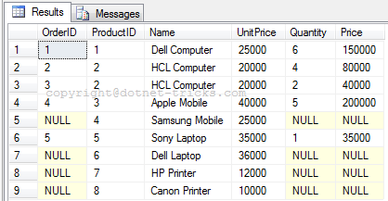

Right Outer Join
- SELECT t1.OrderID AS OrderID , t0.ProductID , t0.Name , t0.UnitPrice , t1.Quantity AS Quantity , t1.Price AS Price
- FROM tblProduct AS t0
- RIGHT OUTER JOIN tblOrder AS t1 ON t0.ProductID = t1.ProductID
- ORDER BY t0.ProductID
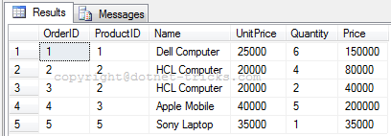

Full Outer Join
- SELECT t1.OrderID AS OrderID , t0.ProductID , t0.Name , t0.UnitPrice , t1.Quantity AS Quantity , t1.Price AS Price
- FROM tblProduct AS t0
- FULL OUTER JOIN tblOrder AS t1 ON t0.ProductID = t1.ProductID
- ORDER BY t0.ProductID
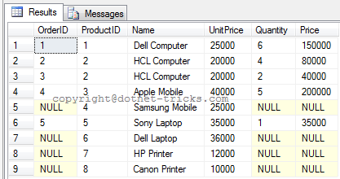

Cross Join
- SELECT t1.OrderID, t0.ProductID, t0.Name, t0.UnitPrice, t1.Quantity, t1.Price
- FROM tblProduct AS t0, tblOrder AS t1
- ORDER BY t0.ProductID
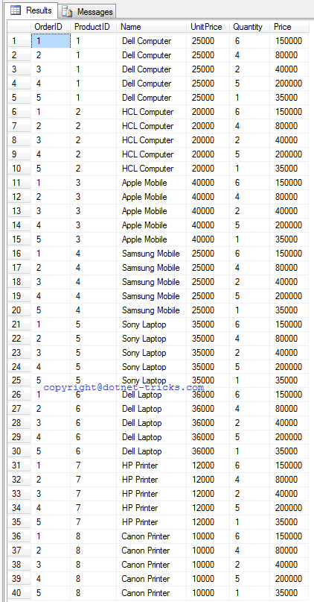

Self Join
To understand Self Join, suppose we following two tables and data in these two tables is shown in figure.
- CREATE TABLE emp
- (
- id int NOT NULL primary key,
- name varchar(100) NULL,
- designation varchar(50) NULL,
- supid int foreign key references emp(id) ) -- In this table we have a Foreign key supid that references its own Primary Key id. We use it for Self Join
- INSERT INTO emp(id,name,designation) VALUES(1,'mohan','Manger')
- INSERT INTO emp(id,name,designation,supid) VALUES(2,'raj kumar','SE',1)
- INSERT INTO emp(id,name,designation) VALUES(3,'bipul kumar','Manager')
- INSERT INTO emp(id,name,designation,supid) VALUES(4,'mrinal kumar','SE',2)
- INSERT INTO emp(id,name,designation,supid) VALUES(5,'jitendra kumar','SE',2)
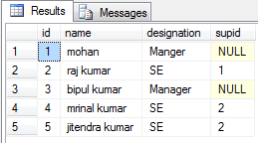
- CREATE TABLE empinfo
- (
- id int primary key,
- address varchar(50) NULL
- )
- INSERT INTO empinfo(id,address) VALUES(1,'Delhi')
- INSERT INTO empinfo(id,address) VALUES(2,'Noida')
- INSERT INTO empinfo(id,address) VALUES(4,'Gurgaon')
- INSERT INTO empinfo(id,address) VALUES(6,'Delhi')
- INSERT INTO empinfo(id,address) VALUES(7,'Noida')
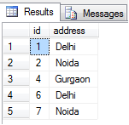
- select e.id,e.name,e.supid as managerid, ei.name as managername from emp e left join emp ei on e.supid=ei.id;
- -- outer keyword is optional
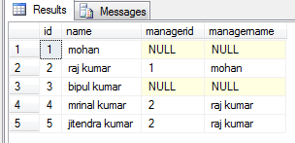

Different Types of SQL Server Views
http://www.dotnettricks.com/learn/sqlserver/different-types-of-sql-server-views:

